To | Attendees of the Global R&D Summit
cc
Prepared by | Peter Bell
Subject: | Programming Competition

The Challenge
I have chosen as our programming challenge a problem that is solvable within two hours. This problem is best solved by recursion. To make it more interesting, I want you all to implement this in a language that very few of you will know.
It’s 2016, and the US presidential election is down to Hilary Clinton versus Donald Trump. The polls are neck-and-neck. In order to move the polls in her favour, Hilary Clinton has decided to do one last mad rush visiting all eastern states within the USA. Eastern states are Minnesota, Iowa, Missouri, Arkansas, and Louisiana and all states to the east of them. This will be followed by an equal dash across all western states if time permits.
In order to appeal to the liberal vote, she has decided to do the trip by bus rather than flying, and not to visit any state more than once. So we need to help her find a route starting in Washington and visiting each state only once. I have left the remote states of Alaska and Hawaii) out of the problem.
In computer science terms, we can represent the USA as a set of nodes representing the states. If two states share a border, then this is represented as an undirected vertex between the nodes. A path that visits every node in the graph only once is called a Hamiltonian cycle. The problem of finding the set of all Hamiltonian cycles in an undirected graph is NP-complete. The first person to solve this problem mathematically was Euler for the bridges of Konigsberg.
Here is an example of graph with the Hamiltonian cycle drawn on it:
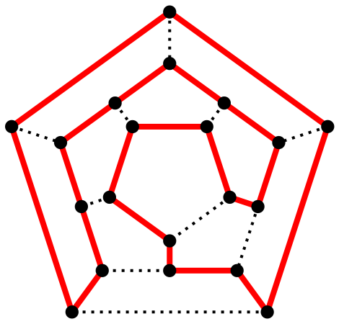

I will provide you with a represention of the directed graph of US mainland states. I also provide a method to remove the western states. This is the map I used to generate the network:
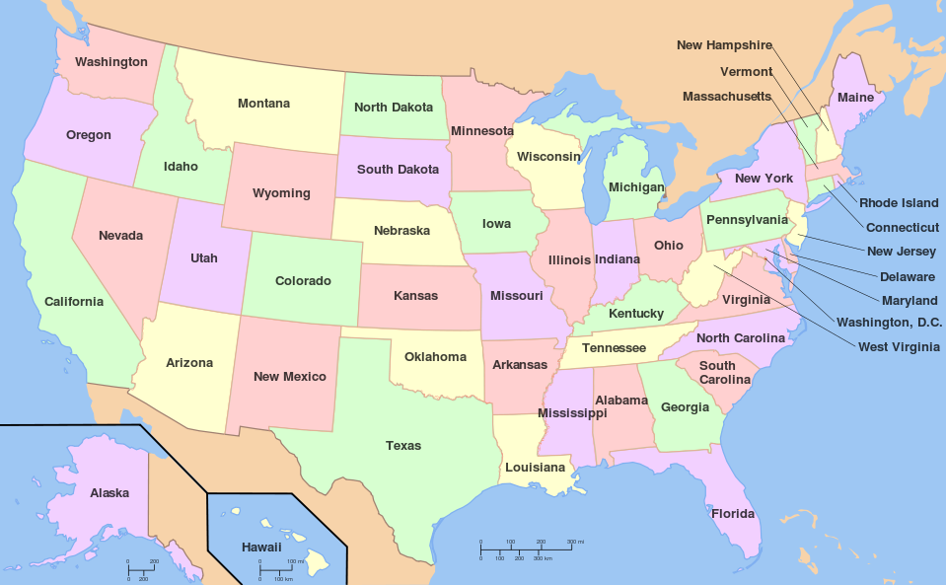

A very quick introduction to Ruby
Ruby is my favourite language and I believe it to be almost perfect. It has certain similarities with Python and Perl, but also has some key differences which make it very attractive. This introduction is not intended to explain the language in all its subtle flavours, but purely focus on the key items needed to implement the algorithm.
Ruby has become famous as the language in which the Web framework Ruby-on-Rails is developed. The advantage of Ruby and Rails is that programmers are much more productive than in more conventional languages and frameworks. This is the reason why many startups initially use Ruby as their initial language. Twitter and Groupon are two famous examples. Ruby’s big disadvantage is execution speed. As it is interpreted, it is much slower than C or C++. Once scale becomes an issue, people often end up re-writing their applications in other languages. Speed is also the reason why we are only tackling half the USA. I found that trying to determine a Hamiltonian path for the entire mainland USA simply took too long.

Ruby is truly object oriented and strongly typed
Unlike Java, C++ or JavaScript, Ruby is a pure object oriented language: everything is an object. Ruby is also strongly typed, but unlike Java or C++ it is not statically typed. Instead, the interpreter does dynamic type checking at runtime.
The key reason this is important is that variables are purely references to objects. As such they do not have a type. In Ruby you declare a variable by using it – this is different from most other programming languages where you have to explicitly declare that you intend to use a variable. For example:
irb(main):001:0> 1.class
=> Fixnum
irb(main):002:0> a = 1
=> 1
irb(main):005:0> a.object_id
=> 3
irb(main):006:0> 1.object_id
=> 3
irb(main):007:0> a = "Now A is a string"
=> "Now A is a string"

This short example shows that 1 is an object. If we assign that object to the variable a, it simply stores a reference to the object 1. We can then decide to assign a to point at a completely different object such as a string.

Syntax Rules
In Ruby the common practice is to put one statement on one line. The new line is a statement terminator (unlike in C++, Java or JavaScript where a ‘;’ needs to be used). Comments start with the ‘#’ and go till the end of the line.

Defining a Class
This shows how we might define a class:
class Hamiltonian
# Constructor
def initialize( g )
@graph = g
end

# set things up for the recursive search.
def find_hamiltonian( start )

end

private

# Find a hamiltonian cycle recursively. Function returns true
# if a cycle has been found
def find_hamiltonian_recursively( current )

end
end

This shows all the key points about class definitions in Ruby. Methods are defined within the class using the def keyword.
In common with variables, class variables are defined simply by using them. A class variable is identified by the use of a preceding @ sign. So in our example @graph is a class variable. One interesting fact about class variables is that if you access a class variable that has not yet been set, it returns the nil object.

Loops
Compared to many other languages, Ruby’s looping structure is fairly simple. You specify the condition at the start or end of the block that must be valid for the loop to continue. You can use break and continue as in other languages:
Here is a somewhat contrived example of a loop:
def power2(n)
i = 0
a = 1
while i < n
a = a*2
i = i + 1
end
return a
end

Ruby has a trick or two up its sleeve that means that programmers make much less use of loops than in other programming languages.

Symbols
Many languages have enumerated types. Ruby has a similar concept: symbols. Symbols are user to represent a value in a concise way. Symbols are identified in the source code simply by prefixing the symbol name with a colon:
:wdc

Unlike in Java or C++, symbols are not grouped into enumerated types but declared globally. The symbol object only exists once in the Ruby system.

Hash Tables
Ruby has a super-class called collections to store multiple objects. The two most important examples of collections in the language are Arrays and Hashes. Ruby programmers do with these two constructs what programmers in other languages often end up doing by creating private classes. For our challenge today, I will use a Hash to hold the graph of how the counties are connected. The following shows a simple hash that is used to map a person to their age (all names and ages are fictitious):
irb(main):002:0> ages = { "Peter" => 20, "Jane" => 5, "James" => 16 }
=> {"Peter"=>20, "Jane"=>5, "James"=>16}
irb(main):003:0> ages["Peter"]
=> 20
irb(main):004:0> ages["Mary"]
=> nil

The Hash defines a mapping from a key to a value. There are no constraints on what either the class of the keys or the values. If we try to call up the value for a key that is not in the table we get the nil value back.
Now we said above, that the value can be any object. So our graph of states is represented as follows:
states = {
:wa => [ :or, :id],
:or => [ :wa, :id, :nv, :ca],
:ca => Set.new( [ :or, :nv, :az ] ),
:id => Set.new( [ :wa, :or, :nv, :ut, :wy, :mt ] ),
:ut => Set.new( [ :id, :nv, :az, :co, :wy ] ),

More lines as above.
}

Arrays and Sets
Arrays, and by extension Sets, work very similar to most other languages including Java and C:
D:\RubyDevKit>irb
irb(main):001:0> a = [ 0, 1, 5, 10 ]
=> [0, 1, 5, 10]
irb(main):002:0> a[0]
=> 0
irb(main):003:0> a[3]
=> 10
irb(main):004:0> a[6]
=> nil
irb(main):005:0> a.push( "Peter" )
=> [0, 1, 5, 10, "Peter"]
irb(main):006:0> a.pop
=> "Peter"
irb(main):007:0>

The main difference to Java and C is that the array elements can be of any type. Secondly, accessing an element that does not exist does not generate an error, but simply returns the nil object.

Iterators
I mentioned above, that in Ruby people write traditional loops much less often that they do in more conventional languages. Instead, Ruby has a powerful mechanism built into the language to allow iterators to be defined in a neat way. Here is a contrived example of using a loop to add all the ages in the Hash.
def combined_age
ages = { "Peter" => 20, "David" => 5, "James" => 16 }
total_age = 0
ages.each do |age|
total_age += age
end
end

Actually, Ruby has an inbuilt method for Hashes that would achieve the same in one method call, but that was not the point. One gotcha to be wary of is the block between the do and end has its own lexical scope. So if you assign to a not yet defined variable in the block, it will no longer exist once the block completes.

Final Tricks: Other methods on Hash, Set and Array that may be useful
There are a couple of other methods that you will probably find useful:
- @unvisited.include?( node ) – returns true if the @unvisited holds the value node.
- @unvisited.empty? – returns true if @unvisited contains any values.
- @unvisited.delete( node ) – removes the node from @unvisited and returns it.
- @unvisited.push( node ) – appends node to @unvisited
- @unvisited.pop – removes the last element from the array and returns it
To output the solution, assuming it is stored in an array, you will need the following statement:
puts "complete journey = #{@journey.join( " -> ") }"

Suggested Algorithm
We need three variables to capture where we have got to:
- Unvisited – the list of nodes yet to be visited
- Journey – an array holding the sequence in which nodes
- Current – the current node from which we are searching for the solution
The algorithm needs to examine for the current node each of the neighbours and check if it has not been visited. If so, the algorithm should recursively visit each neighbour. If a visit yields a solution, we simply finish the algorithm. Otherwise, we eventually return to our predecessor.

The Template
To make the challenge more manageable I have created a template. Here it is:
require 'debugger'
require 'set'

class Hamiltonian
# Constructor
def initialize( g )
# The undirected graph of neighbouring counties is represented as a hash of
# arrays. The key is used to identify a specific county. The returned
# array provides the list of neighbouring counties.
@graph = g
end

# Little test method to ensure the graph is undirected: if :a is a neighbour of
# :b, then :b must be a neighbour of :a
def check_graph
@graph.each_pair do | county, neighbours |
neighbours.each do | neighbour |
if !@graph[ neighbour ].include?( county )
puts " #{county.to_s} -> #{neighbour.to_s} exists, but not #{neighbour.to_s} -> #{county.to_s}"
end
end
end
end

# set things up for the recursive search.
def find_hamiltonian( start )
# Define a list of unvisited counties.
@unvisited = @graph.keys

# We will store the journey taken in the array journey.
@journey = []

# start the recursive hunt
find_hamiltonian_recursively( start )
end

private

# Find a hamiltonian cycle recursively. Function returns true
# if a cycle has been found
def find_hamiltonian_recursively( current )

Your code here.

end
end

scottish_counties = {
:aberdeenshire => Set.new( [ :banffshire, :inverness_shire, :perthshire, :angus, :kincardineshire ] ),

Rest of table removed for space reasons

}

h = Hamiltonian.new( scottish_counties )
h.check_graph

h.find_hamiltonian( :fife )

Scoring criteria
Your task is clearly to write the algorithm. I will give points for the correct algorithm. However, I will also be giving points for sensible variable names, and for good commenting. I will give additional points, if you have built some degree of testing into your solution.

